**SOFTWARE ENGINEERING  
LAB # 01  
CLASS TASK**

**Name: Anas Zahid  
Section: 6C  
Roll number: 2018-CS-140  
  
Q1 A man bought a toy for Rs. 325 and sold the same for Rs. 458. Explain how we can find if he has made a profit or a loss. Draw a program flow chart  
Hint,   
Finding profit or loss when CP = 325 and SP = 458  
Start  
Read CP=325  
Read SP= 458  
Condition:  
Is 458 &gt; 325?  
Profit= 458-325  
Profit= Rs. 133  
End**

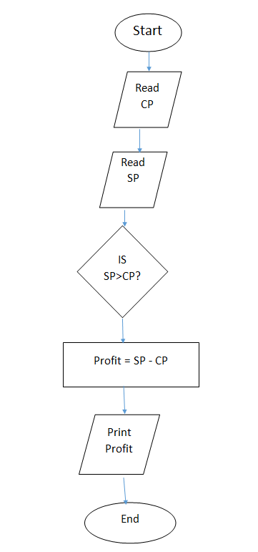

**2) Create a flow chart of table 12**

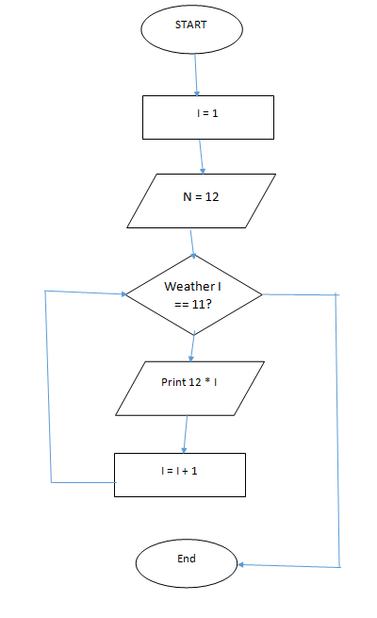

**Q3.The following flowchart classifies animals as herbivore or carnivore. Lion is a meat eating animal.**

**Elephants eat only plants. Study the flowchart and answer the questions  
a. Indicate each element of the flowchart by putting ‘I’ for input, ‘O’ for output, ‘D’ for decision in the circles provided next to the boxes.  
b. Put a rectangle around the decision structure.  
c. What is the condition which classifies an animal as carnivore?  
d. Write the Execution steps if the input is a Lion.  
e. What is the condition which classifies an animal as herbivore?  
f. Write the Execution steps if the input is an elephant.**

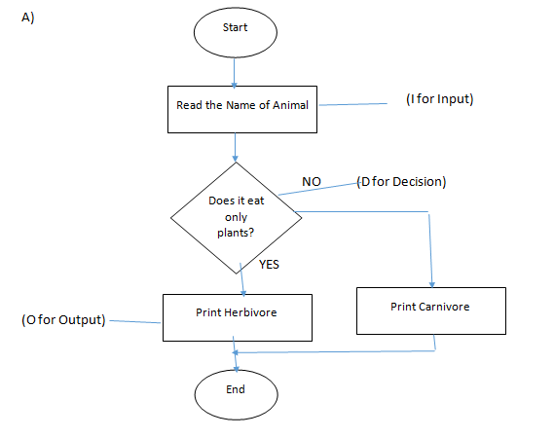

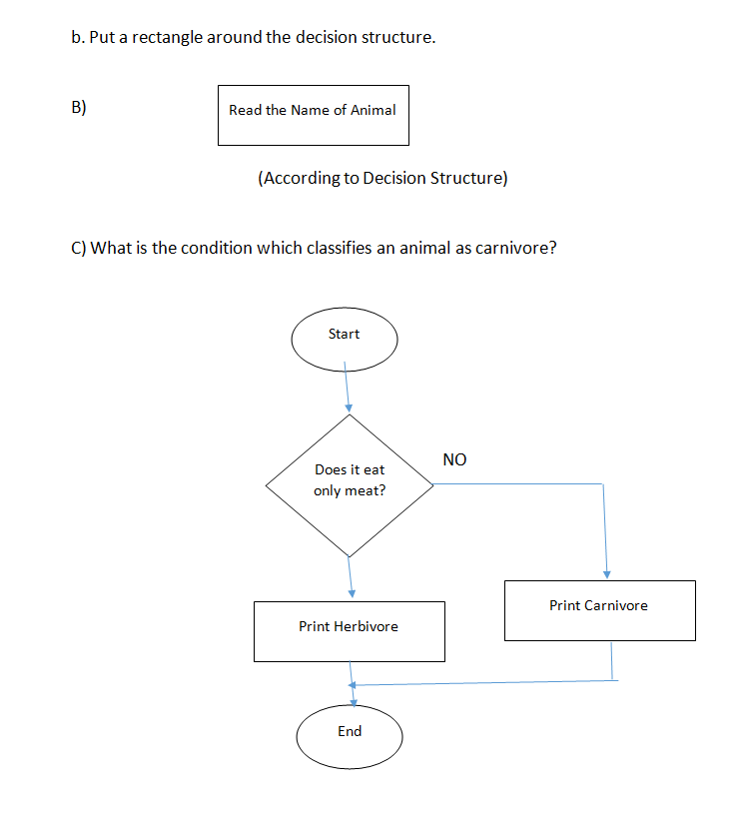

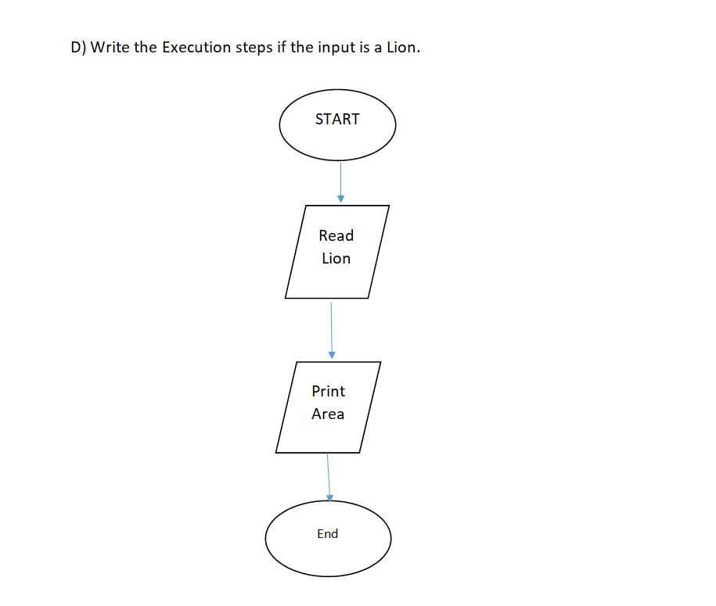

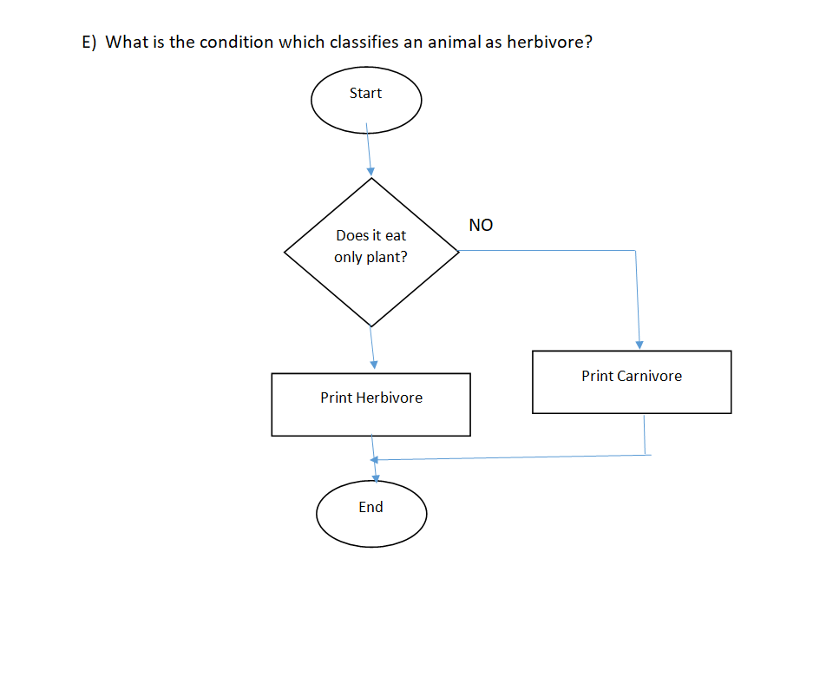

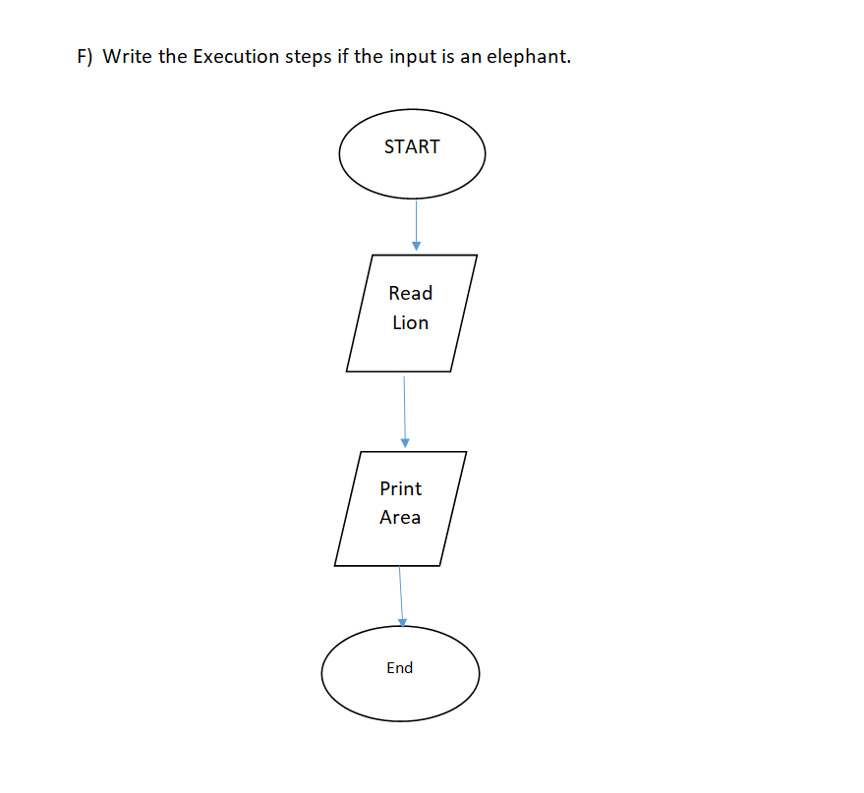

**Q4: Draw a flowchart of an algorithm to read two numbers and find their sum.**

**Inputs to the algorithm:**

**First num1.**

**Second num2.**

**Expected output:**

**Sum of the two numbers.**

**Algorithm:**

**Step1: Start**

**Step2: Read\input the first num1.**

**Step3: Read\input the second num2.**

**Step4: Sum num1+num2 // calculation of sum**

**Step5: Print Sum**

**Step6: End**

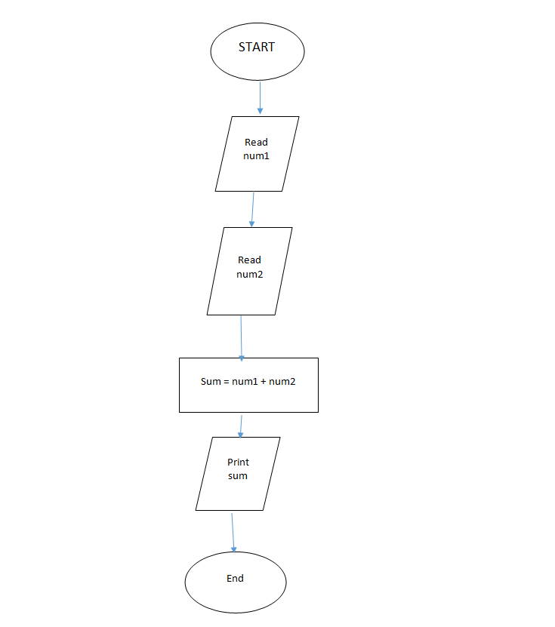

**Q5. Draw a flow chart Convert temperature Fahrenheit to Celsius  
Inputs to the algorithm: Temperature in Fahrenheit  
Expected output:   
Temperature in Celsius**

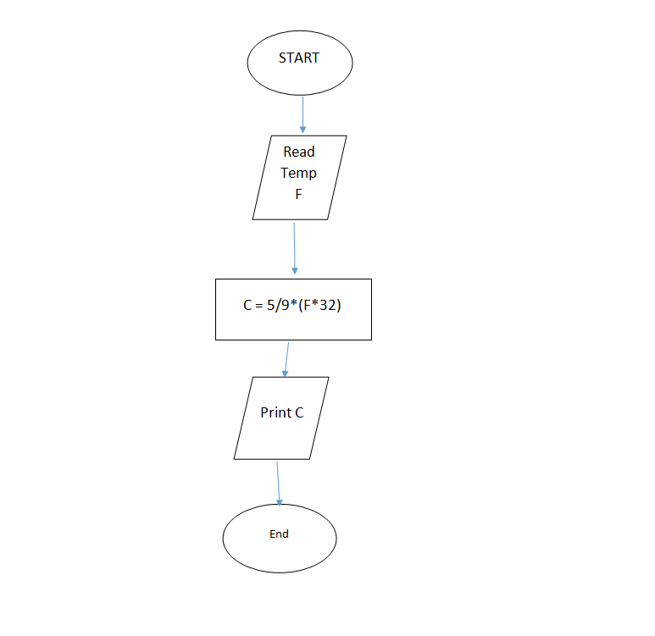

**Q6.Draw a flow chart for finds the greater number between two numbers.**

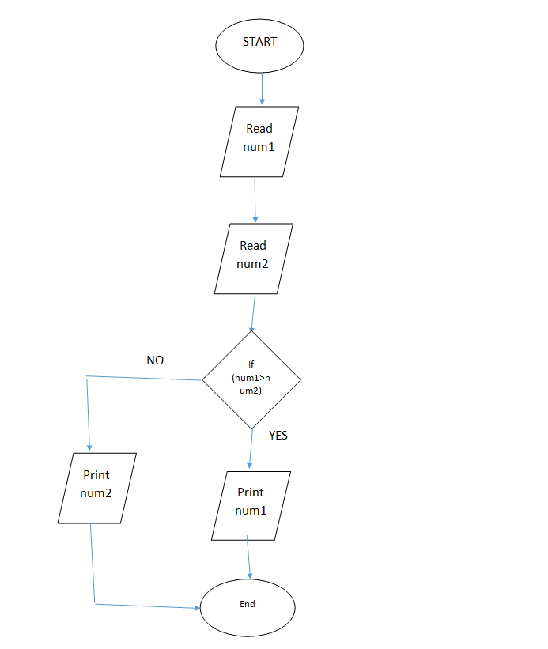

**Q7. Draw a flow chart to find the area of a circle of radius r.**

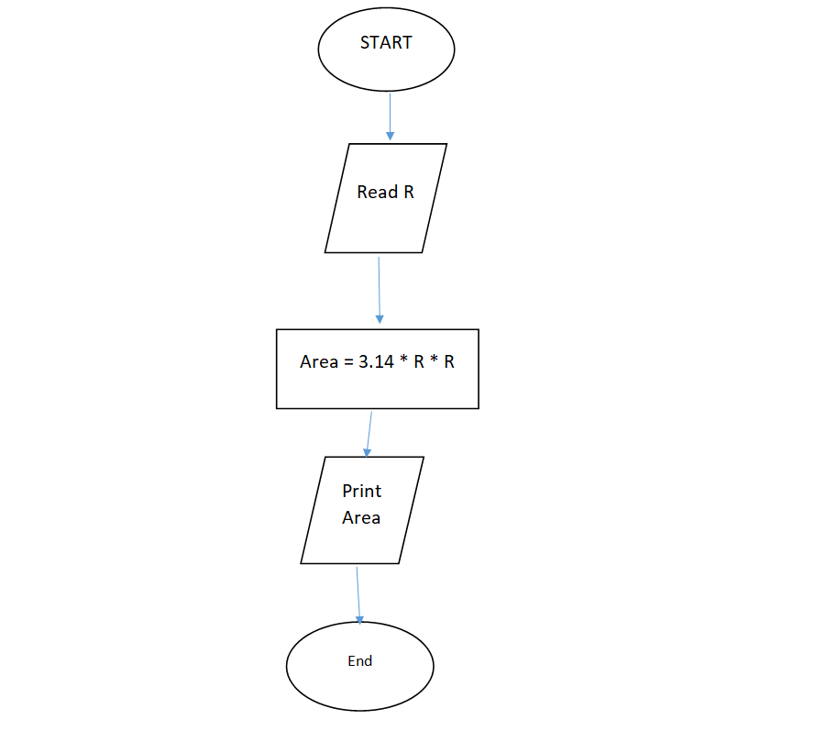

**Q8.Draw a flow chart Algorithm for finds the greater number between two numbers.**

**Answer:**   
  
ALGOPRITHM:

Finding the greater number between two numbers.  
When num1 = 325 and num2 = 458

Start

Read num1=325

Read num2= 458

Condition:

If (num2 > num1)

Print num2;

Else

Print num1;

End

**Q9.Flowchart for the problem of printing even numbers between 9 and 100:**

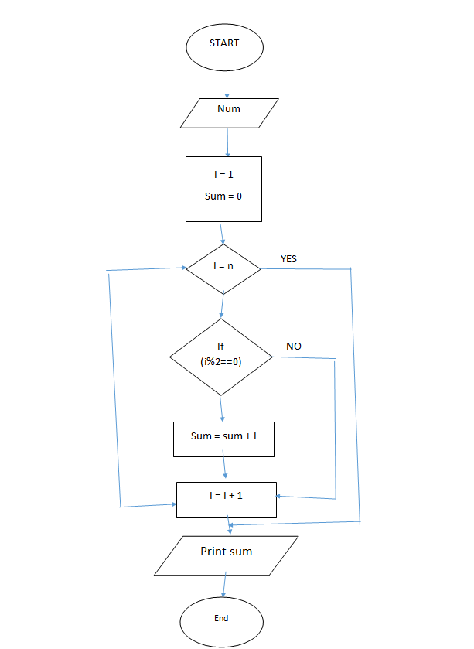

**Q10. Flowchart for the calculate the average from 25 exam scores**.

